Hospital-Level Variation in Liver Radiodensity and Chemotherapy-Induced
Toxicities in Colon Cancer Patients
Abdullah Abdullah & Noah Bos
Introduction
Capecitabine and oxaliplatin are commonly used chemotherapeutic agents in the treatment of stage II and stage III colorectal cancer, either as monotherapy or in combination (CAPOX regimen). Although effective, both agents are associated with clinically relevant toxicities that may lead to dose reductions, treatment delays, or early discontinuation. Capecitabine-related toxicities frequently include hand-foot syndrome and gastrointestinal side-effects (Scheithauer et al., 2003; Iacovelli et al., 2014). In contrast, oxaliplatin is particularly associated with peripheral neuropathy, a dose-limiting toxicity that develops in a large proportion of treated patients and may persist over time (Renting et al., 2024). It is, therefore, critical to identify factors that influence treatment-related toxicities and this remains an important clinical and research priority.
Recent analyses within the COLON cohort, a prospective multicentre cohort study conducted in the Netherlands, showed that circulating folic acid and folic acid supplement use were associated with an increased risk of capecitabine-induced toxicities among patients with colon or rectal cancer (Kok et al., 2024). Additional work within this cohort has examined nutritional determinants of chronic oxaliplatin-induced toxicities. These findings suggest that metabolic and nutritional factors may predispose patients to chemotherapy-induced toxicities, although causal relations cannot be established within observational designs.
In the current project, we focus on liver fat accumulation, measured as liver radiodensity on computed tomography (CT) scans taken at the time of diagnosis, as a potential determinant of chemotherapy-induced side-effects. The data originate from the prospective COLON study, in which patients newly diagnosed with colorectal cancer were recruited from 11 hospitals in the Netherlands (Winkels et al., 2014). While inclusion of patients from different hospitals improves generalizability, it also introduces potential heterogeneity. Differences in CT scanner characteristics, imaging protocols, and calibration procedures across hospitals may lead to systematic variation in measured liver radiodensity. In addition, differences in patient characteristics across hospitals (such as age, tumour stage or general health status) or differences in clinical practices across hospitals may influence the occurrence of treatment-related toxicities.
If hospital-level differences are present, they may affect the estimated association between liver radiodensity and risk of chemotherapy-induced toxicities. Ignoring such variation could lead to biased estimates or misleadingly precise confidence intervals. Therefore, it is important to assess whether hospital-level effects exist and to determine how they influence statistical inference. The primary aim of this paper is to evaluate how hospital-level variation influences the estimated risk and timing of chemotherapy-induced toxicities in relation to liver radiodensity at diagnosis within a multi-centre observational cohort. Specifically, we address the following main research question:
RQ: How does hospital-level variation influence the estimated association between liver radiodensity and time to chemotherapy-induced toxicity?
The study specifically answers the following sub-questions:
- Are there systematic differences between hospitals in liver radiodensity measurements and/or toxicity outcomes?
- How does accounting for hospital-level variation affect the estimated association between liver radiodensity and toxicity?
- How should hospital-level heterogeneity be incorporated when interpreting the findings?
Methods
This section describes the study design, variables, and statistical approach used to investigate the association between liver radiodensity and time to chemotherapy-induced toxicity. Particular attention is given to the multicentre nature of the data and the potential role of hospital-level variation.
Participants and Study Design
The data originate from a prospective multicentre cohort study conducted in the Netherlands, in which patients diagnosed with colorectal cancer were recruited from multiple hospitals and followed during chemotherapy treatment. The study has an observational design, and no intervention was assigned as part of this analysis. Patients were included if they received chemotherapy involving capecitabine, oxaliplatin, or a combination of both (CAPOX regimen), and if computed tomography (CT) scans at the time of diagnosis were available. Because not all patients received the same treatment, separate analytic samples were defined for each toxicity endpoint. Patients were excluded from a given analysis if they were not at risk for the corresponding toxicity or if information on time to toxicity or event occurrence was missing.
Measurements
Outcome: Time to Dose-Limiting Toxicity
The primary outcome is time to first occurrence of dose-limiting toxicity during chemotherapy treatment. Time was operationalised as the number of chemotherapy cycles completed before the onset of toxicity. For each endpoint, the outcome consists of a time variable and an event indicator specifying whether toxicity occurred. Patients who did not experience toxicity during the observed treatment period were treated as censored at their last completed cycle. Three toxicity outcomes were considered: toxicity associated with capecitabine, toxicity associated with oxaliplatin, and toxicity associated with the combined CAPOX regimen. Dose-limiting toxicity was defined as any toxicity event leading to a dose reduction, treatment delay, or premature discontinuation of chemotherapy. Each outcome defines a separate risk set, as only patients receiving the corresponding treatment are at risk for that specific toxicity.
Exposure: Liver Radiodensity
The main exposure is liver radiodensity measured on CT scans at the time of diagnosis. Radiodensity is expressed in Hounsfield Units (HU), with lower values indicating higher liver fat content. Liver radiodensity was analysed as a continuous variable.
Covariates
The analyses adjust for a set of patient and treatment characteristics that may influence the risk of chemotherapy-induced toxicity, including age at diagnosis, sex, body mass index, smoking status, and starting dose of chemotherapy. Starting dose was defined in a treatment-specific manner depending on the toxicity endpoint considered.
Hospital
Patients were recruited from multiple hospitals. Hospital was treated as a grouping variable to account for potential differences in imaging procedures, patient characteristics, and clinical practices across centres.
Statistical Analysis
Descriptive Analysis
Descriptive statistics were used to summarise the study population and to explore the distribution of toxicity outcomes across endpoints and hospitals. Event rates were calculated for each toxicity endpoint, and variation in toxicity occurrence across hospitals was examined.
Differences in liver radiodensity across hospitals were assessed using one-way analysis of variance (ANOVA). This analysis evaluates whether mean radiodensity values differ between hospitals and provides insight into potential measurement heterogeneity across centres.
Survival Analysis
The association between liver radiodensity and time to dose-limiting toxicity was analysed using Cox proportional hazards regression models. Separate models were fitted for each toxicity endpoint (capecitabine, oxaliplatin, and CAPOX), using endpoint-specific datasets that include only patients at risk for the respective toxicity. The primary exposure in all models was liver radiodensity. Models were adjusted for age, sex, body mass index, smoking status, and treatment-specific starting dose. To account for hospital-level differences, stratified Cox models were used. Stratification was preferred over a frailty model because the primary aim was to estimate the within-hospital effect of liver radiodensity rather than to quantify between-hospital variability as a parameter of interest. Stratification makes no distributional assumptions about hospital-level effects and is therefore a more conservative and robust approach in this setting. This approach allows the baseline hazard to vary across hospitals while estimating a common effect of liver radiodensity across centres.
Model Assumptions and Sensitivity Analyses
The proportional hazards assumption was assessed using standard diagnostic methods based on residuals. This assumption implies that the effect of liver radiodensity on toxicity risk remains constant over time. Potential issues related to missing covariate data were evaluated. Missingness in covariate data was assessed prior to analysis. No imputation was performed, as the proportion of missing values across covariates was low and unlikely to meaningfully affect the results. Outcome variables and the main exposure were not imputed. In addition, exploratory analyses will examine whether the association between liver radiodensity and toxicity differs across hospitals.
Software
All analyses were conducted using R, with survival models estimated using the survival package.

Results
This section presents the main findings of the analysis, starting with a description of the study sample and toxicity outcomes, followed by an assessment of hospital-level variation, and finally the results of the survival models examining the association between liver radiodensity and time to toxicity.
Sample Characteristics and Event Rates
The analysis included patients receiving capecitabine (CAP), oxaliplatin (OXA), or a combination of both (CAPOX). Because not all patients received each treatment, separate datasets were constructed for each toxicity endpoint. The table below presents the number of patients and event rates captured for each treatment.
Table 1: Observed Toxicity Rates by Endpoint
Endpoint | N | Events | Censored
CAP | 344 | 181 | 163
OXA | 311 | 254 | 57
CAPOX | 359 | 257 | 102

Across the three endpoints, dose-limiting toxicity was a common outcome. Approximately half of the patients experienced capecitabine-related toxicity, while the proportion was higher for oxaliplatin and CAPOX-related toxicity. The number of observed events was sufficient to support time-to-event analyses for all endpoints.
Variation in Toxicity Across Hospitals
Substantial variation in toxicity rates was observed across hospitals. The proportion of patients experiencing toxicity ranged from approximately one-third to as high as four-fifths across centres. This indicates that baseline risk of toxicity differs between hospitals. Table 2 shows the variation in toxicity across hospitals.
Table 2: Distribution of Toxicity Outcomes by Hospital
Hospital | N | Events | Event % | Censored
A | 70 | 37 | 52.9 | 33
E | 58 | 34 | 58.6 | 24
J | 43 | 25 | 58.1 | 18
C | 35 | 16 | 45.7 | 19
I | 30 | 10 | 33.3 | 20
K | 25 | 16 | 64.0 | 9
H | 23 | 8 | 34.8 | 15
D | 18 | 9 | 50.0 | 9
F | 16 | 10 | 62.5 | 6
G | 16 | 8 | 50.0 | 8
B | 10 | 8 | 80.0 | 2

These differences may reflect variation in patient characteristics, treatment practices, or reporting procedures across hospitals. The presence of such variation highlights the importance of accounting for hospital-level differences in the statistical analysis.
Variation in Liver Radiodensity Across Hospitals
Visual inspection of liver radiodensity distributions indicated differences across hospitals. This is presented in figure 1 below.
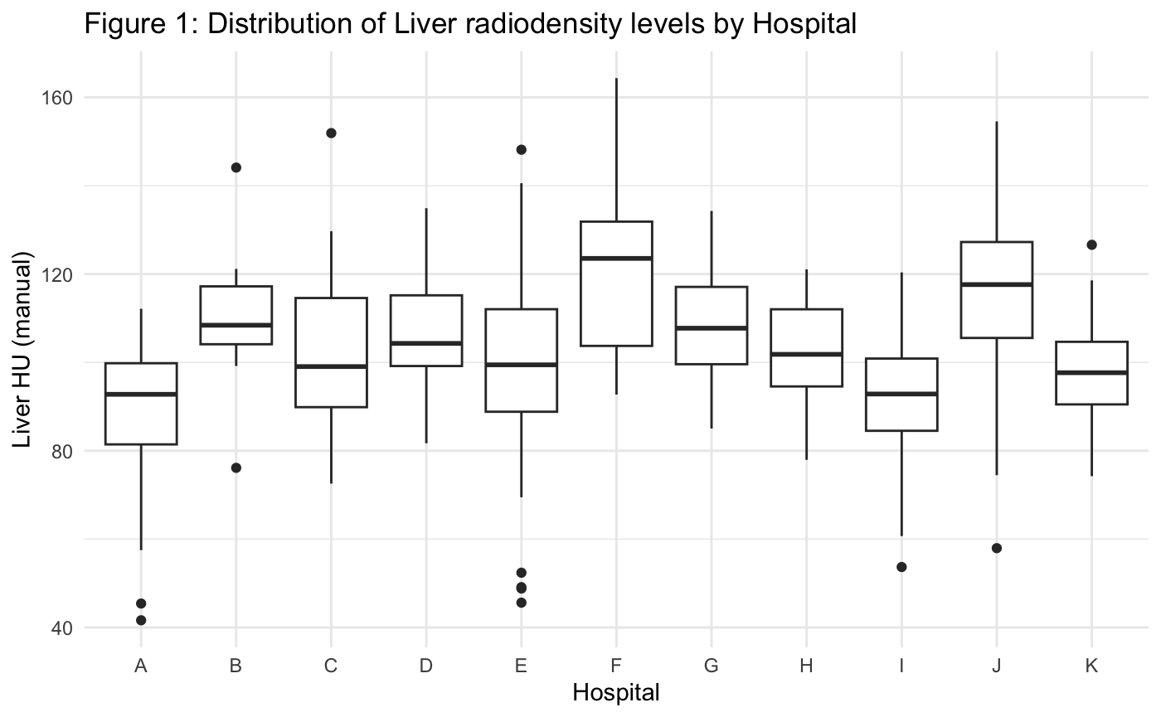
This was also confirmed by a one-way analysis of variance (ANOVA), which showed that mean liver radiodensity differed significantly between hospitals (F = 12.1, p < 0.001). Approximately one quarter of the variability in liver radiodensity was explained by hospital-level differences. Table 3 below presents the ANOVA test results.
Table 3: ANOVA Test Results
 | Df | Sum Sq | Mean Sq | F value | Pr(>F)
hospital | 10 | 32418.09 | 3241.8086 | 12.06797 | 0
Residuals | 348 | 93482.95 | 268.6292

These findings indicate that liver radiodensity measurements are not directly comparable across hospitals and may be influenced by differences in imaging procedures or patient populations. This suggests that hospital may act as a confounding factor in the association between liver radiodensity and toxicity.
Time to Toxicity
Kaplan-Meier curves were used to describe the unadjusted time to dose-limiting toxicity across chemotherapy cycles. Across all endpoints, the probability of remaining free from toxicity declined rapidly during the early treatment cycles, indicating that most toxicities occurred early in treatment. In later cycles, estimates became less stable due to the smaller number of patients remaining at risk. These patterns support the use of survival analysis methods and highlight the clinical relevance of early treatment tolerance. These Kaplan-Meier curves for each endpoint are present in the figure below.
Figure 2: Kaplan-Meier curves for Time to Toxicity
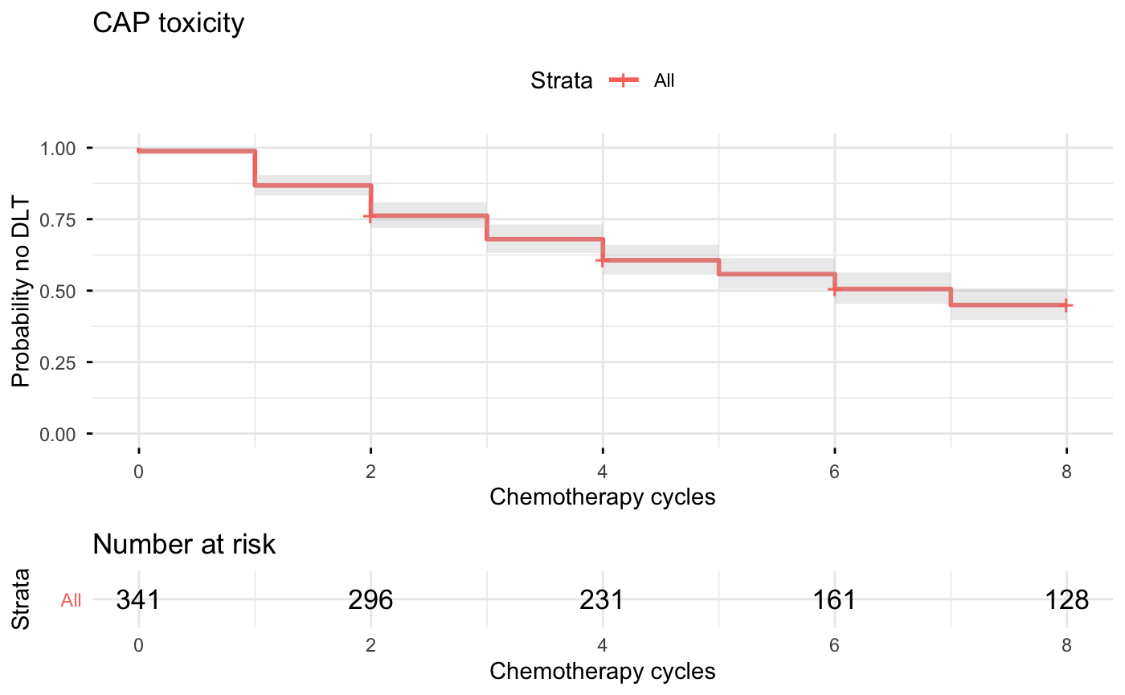
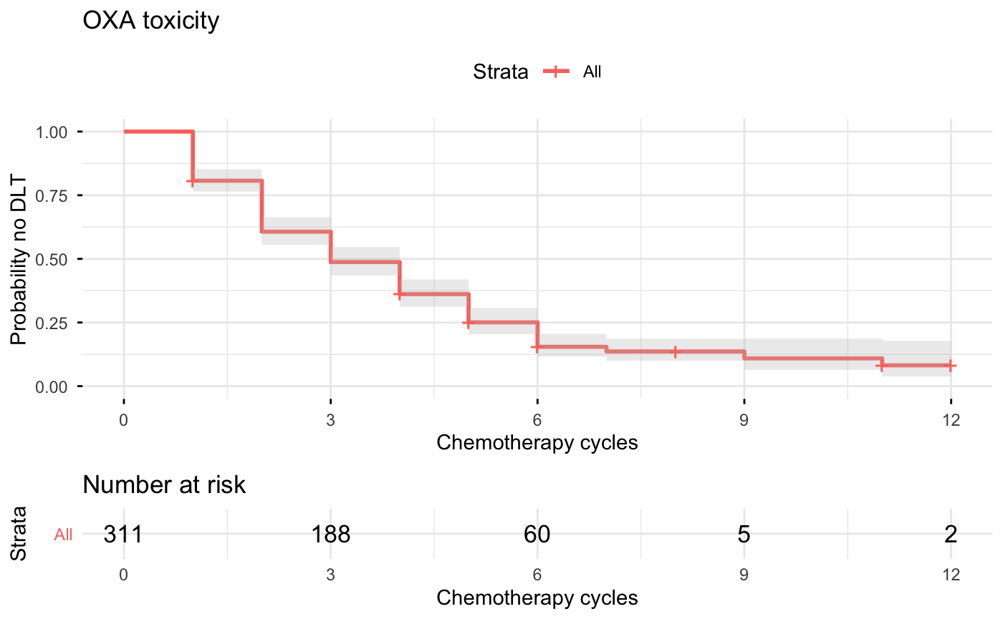
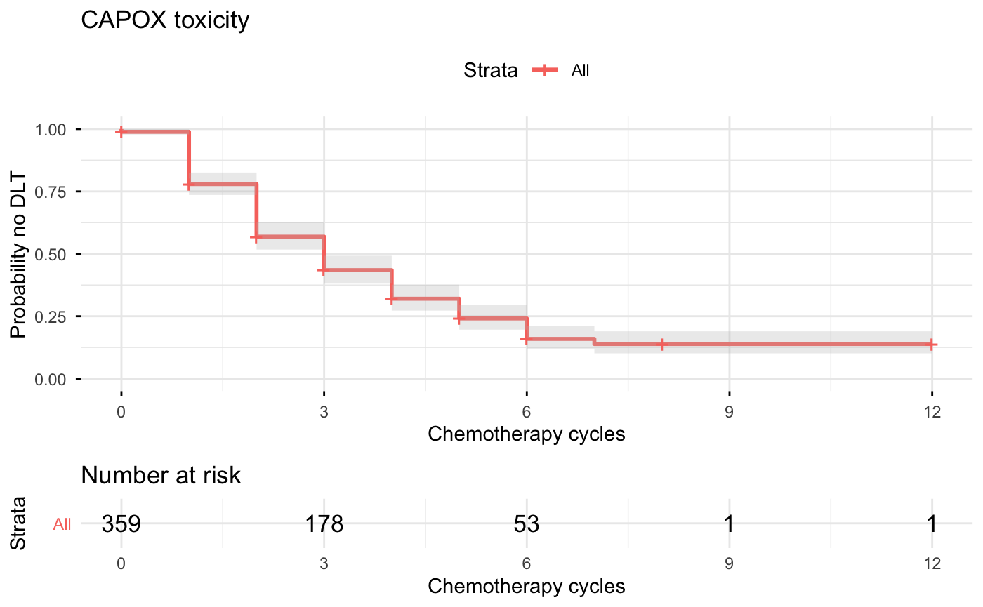
Association between Liver Radiodensity and Toxicity
As shown in the descriptive analysis, both liver radiodensity and toxicity rates varied across hospitals, suggesting potential differences in measurement procedures, patient populations, or clinical practices. These differences could confound the association between liver radiodensity and toxicity if not properly accounted for. The association between liver radiodensity and time to toxicity was assessed using Cox proportional hazards models, adjusted for age, sex, body mass index, smoking status, and treatment-specific starting dose. To address this, Cox proportional hazards models were stratified by hospital. Stratification allows each hospital to have its own baseline hazard function, meaning that comparisons are made within hospitals rather than between hospitals. In this way, the estimated effects (e.g., liver radiodensity) are not influenced by systematic differences across centres. Table 4 presents the estimated hazard ratios for liver radiodensity.
Table 4: Adjusted Association between Liver Radiodensity and Time to Toxicity
Endpoint | Model Specification | Hazard Ratio (95% CI) | p-value
CAP | Stratified by hospital | 1.00 (0.99 - 1.02) | 0.38
OXA | Stratified by hospital | 1.01 (1.00 - 1.02) | 0.06
CAPOX | Stratified by hospital | 1.01 (1.00 - 1.02) | 0.22

The results show that across all endpoints, hazard ratios for liver radiodensity were close to 1 and are not statistically significant. These findings suggest that although hospitals differ in terms of liver radiodensity measurements and baseline toxicity risk, these differences do not meaningfully influence the association between liver radiodensity and toxicity. In other words, the absence of a clear relationship between liver radiodensity and toxicity is consistent within hospitals and is not driven by differences between centres.
Model Diagnostics
The proportional hazards assumption of the Cox regression model was assessed using Schoenfeld residual tests. This assumption implies that the effect of each predictor on the risk of toxicity remains constant over time. In addition, visual inspection of the residual plots did not indicate any systematic patterns over the course of treatment.
Table 5 presents the results of the Schoenfeld residual tests for each variable included in the model. The table reports the test statistic (chisq), degrees of freedom (df), and corresponding p-values. A non-significant p-value (typically p > 0.05) indicates no evidence against the proportional hazards assumption.
Table 5: Checking the Proportional Hazards Model Assumptions
 | chisq | df | p
liverHU_manual | 0.2255962 | 1 | 0.6348086
Age | 0.2120542 | 1 | 0.6451621
Sex | 0.7255615 | 1 | 0.3943257
BBMI | 0.7826862 | 1 | 0.3763209
BSMOKER | 0.1230178 | 2 | 0.9403446
GLOBAL | 2.0444171 | 6 | 0.9155685
Notes: liverHU_manual = liver radiodensity measured from CT scans (used as a proxy for liver fat), Age = age of the patient at diagnosis, Sex = biological sex of the patient, BBMI = body mass index (BMI) at baseline, BSMOKER = smoking status at baseline (categorised variable), and GLOBAL = an overall test assessing the proportional hazards assumption for the full model

All p-values are well above the conventional threshold of 0.05, indicating no evidence that the proportional hazards assumption is violated for any of the variables or for the model as a whole. These findings support the validity of the Cox model and suggest that the estimated hazard ratios can be interpreted as constant over the treatment period.
Summary of Findings
Taken together, the results show that while both liver radiodensity and toxicity rates vary across hospitals, liver radiodensity itself is not a strong predictor of chemotherapy-induced toxicity. After accounting for patient characteristics and hospital-level differences, the estimated effects of liver radiodensity were small and not clinically meaningful. Other clinical factors, such as age, smoking status, and treatment dose, showed stronger and more consistent associations with toxicity outcomes.

References
Iacovelli, R., Pietrantonio, F., Palazzo, A., Maggi, C., Ricchini, F., de Braud, F., et al. (2014). Incidence and relative risk of grade 3 and 4 diarrhoea in patients treated with capecitabine or 5-fluorouracil: A meta-analysis of published trials. British Journal of Clinical Pharmacology, 78(6), 1228-1237.
Kok, D. E., van Duijnhoven, F. J. B., Lubberman, F. J. E., McKay, J. A., van Lanen, A., Winkels, R. M., et al. (2024). Intake and biomarkers of folate and folic acid as determinants of chemotherapy-induced toxicities in patients with colorectal cancer: A cohort study. The American Journal of Clinical Nutrition, 119, 294-301.
Renting, L., Zwart, N. R. K., Ueland, P. M., McCann, A., Ulvik, A., van Halteren, H. K., Lubberman, F. J. E., Winkels, R. M., Kampman, E., & Kok, D. E. (2024). Vitamin B6 status and chronic chemotherapy-induced peripheral neuropathy: a prospective cohort study among patients with non-metastatic colorectal cancer receiving oxaliplatin-based chemotherapy. BMJ Oncology, 3: e000462.
Scheithauer, W., McKendrick, J., Begbie, S., Borner, M., Burns, W. I., Burris, H. A., et al. (2003). Oral capecitabine as an alternative to intravenous 5-fluorouracil-based adjuvant therapy for colon cancer: Safety results of a randomized phase III trial. Annals of Oncology, 14(12), 1735-1743.
Winkels, R. M., Heine-Bröring, R. C., van Zutphen, M., van Harten-Gerritsen, S., Kok, D. E., van Duijnhoven, F. J. B., et al. (2014). The COLON study: Colorectal cancer: Longitudinal, Observational study on Nutritional and lifestyle factors that may influence colorectal tumour recurrence, survival and quality of life. BMC Cancer, 14, 374.

